Grayline Docks
DISTRICT: Tacoma Industrial District
LOCATION: Duwamish River Industrial Corridor
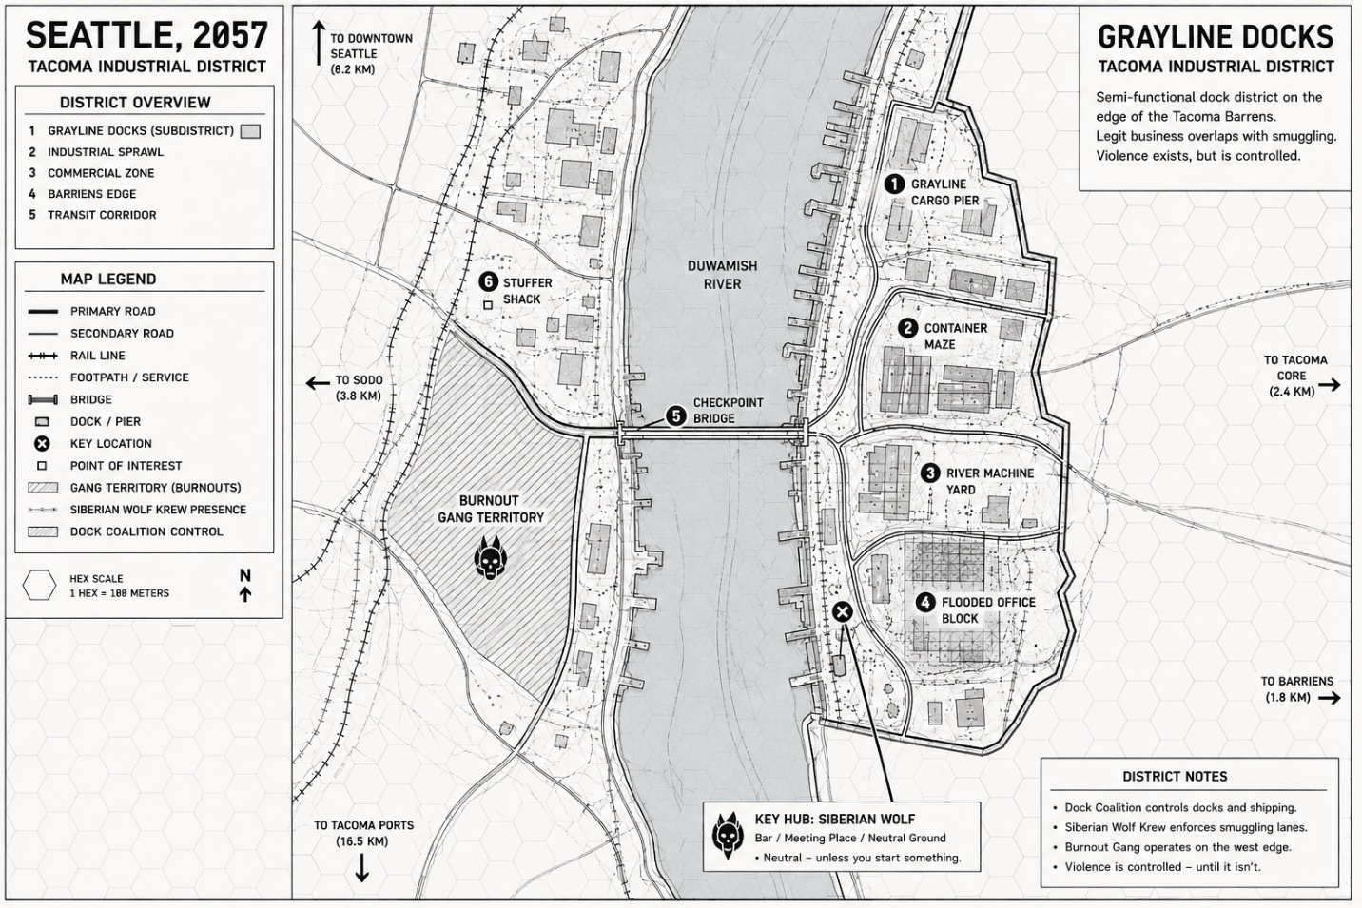============================================================
GRAYLINE DOCKS — OPERATIONAL MAP REFERENCE
RECREATION / STRUCTURAL DOCUMENT
============================================================

MAP TYPE
------------------------------------------------------------
Operational district map

Purpose:
- Mid-scale navigation
- District awareness
- Facility relationship mapping
- Operational movement tracking

STYLE
------------------------------------------------------------
- Black-and-white blueprint aesthetic
- Minimalist industrial line-art
- Hex overlay
- Thin road and structure lines
- Sparse terrain detail
- Printer-friendly
- No heavy shading except territory overlays

============================================================
MAP ORIENTATION
============================================================

NORTH
------------------------------------------------------------
Top of map

REFERENCE ARROWS
------------------------------------------------------------
Northwest:
→ Downtown Seattle (6.2 km)

West:
→ SoDo (3.8 km)

Southwest:
→ Tacoma Ports (16.5 km)

East:
→ Tacoma Core (2.4 km)

Southeast:
→ Barrens (1.8 km)

============================================================
PRIMARY GEOGRAPHIC STRUCTURE
============================================================

CORE FEATURE
------------------------------------------------------------
Duwamish River runs vertically through center of map.

River Characteristics:
- wide industrial waterway
- straight north-south flow
- large enough for cargo traffic
- visually divides district into east/west sectors

MAP BALANCE
------------------------------------------------------------
River occupies approximately:
- 25–30% of total map width

Landmasses:
- west bank narrower
- east bank broader and more developed

============================================================
WEST BANK STRUCTURE
============================================================

GENERAL CHARACTER
------------------------------------------------------------
Sparse industrial spread with fragmented development.

FEATURES
------------------------------------------------------------
- scattered small structures
- broken road network
- rail corridor
- gang territory
- low-density industrial lots

PRIMARY ELEMENTS
------------------------------------------------------------
ROAD NETWORK
------------------------------------------------------------
- one major north-south road
- several curved secondary roads
- irregular intersections
- low urban density

BURNOUT GANG TERRITORY
------------------------------------------------------------
Large shaded territorial block.

Location:
- southwest-central section of west bank

Shape:
- wedge-shaped
- bounded by roads and river

Visual:
- diagonal territory hatch pattern
- gang emblem centered

SIZE
------------------------------------------------------------
Approximately:
- 20–25% of west-bank area

STUFFER SHACK
------------------------------------------------------------
Position:
- north-central west bank
- near major road

Visual:
- small isolated commercial structure

============================================================
EAST BANK STRUCTURE
============================================================

GENERAL CHARACTER
------------------------------------------------------------
Dense industrial dock district.

FEATURES
------------------------------------------------------------
- structured road grid
- dock infrastructure
- warehouses
- cargo zones
- industrial compounds

SHORELINE
------------------------------------------------------------
Irregular industrial seawall edge.

Contains:
- multiple dock protrusions
- cargo slips
- loading piers

============================================================
PRIMARY DISTRICT FLOW
============================================================

LAYOUT PROGRESSION (NORTH TO SOUTH)
------------------------------------------------------------

1. Grayline Cargo Pier
2. Container Maze
3. River Machine Yard
4. Flooded Office Block

These locations form a descending industrial corridor.

============================================================
1. GRAYLINE CARGO PIER
============================================================

POSITION
------------------------------------------------------------
Northeast section of map.

STRUCTURE
------------------------------------------------------------
Large rectangular cargo facility.

FEATURES
------------------------------------------------------------
- dock frontage
- multiple warehouse blocks
- cargo staging spaces
- large road access

PIERS
------------------------------------------------------------
Several short loading piers extend into river.

============================================================
2. CONTAINER MAZE
============================================================

POSITION
------------------------------------------------------------
Central-east district.

STRUCTURE
------------------------------------------------------------
Dense rectangular cargo yard.

FEATURES
------------------------------------------------------------
- stacked container rows
- narrow corridors
- layered access paths

VISUAL DENSITY
------------------------------------------------------------
One of densest map sections.

ROAD ACCESS
------------------------------------------------------------
Connected north and south by main industrial roadway.

============================================================
3. RIVER MACHINE YARD
============================================================

POSITION
------------------------------------------------------------
South-central east bank.

STRUCTURE
------------------------------------------------------------
Industrial fabrication complex.

FEATURES
------------------------------------------------------------
- clustered rectangular buildings
- machinery yard
- open industrial spaces
- heavier structure concentration

VISUAL CHARACTER
------------------------------------------------------------
Dense but less organized than container maze.

============================================================
4. FLOODED OFFICE BLOCK
============================================================

POSITION
------------------------------------------------------------
Southeast edge of district.

STRUCTURE
------------------------------------------------------------
Large damaged office/industrial block.

FEATURES
------------------------------------------------------------
- partially submerged sections
- broken geometry
- enclosed perimeter roads
- isolated southern position

VISUAL CHARACTER
------------------------------------------------------------
More decayed and fragmented than northern structures.

============================================================
ROAD NETWORK
============================================================

PRIMARY ROADS
------------------------------------------------------------
- thick black lines
- connect all major industrial zones
- mostly north-south flow

SECONDARY ROADS
------------------------------------------------------------
- thinner lines
- connect structures internally
- irregular industrial routing

CHARACTERISTICS
------------------------------------------------------------
- curved industrial road design
- practical freight routing
- few straight city-grid lines

============================================================
CHECKPOINT BRIDGE
============================================================

POSITION
------------------------------------------------------------
Center of map.

FUNCTION
------------------------------------------------------------
Primary east-west crossing.

STRUCTURE
------------------------------------------------------------
Straight bridge spanning river.

FEATURES
------------------------------------------------------------
- road checkpoint
- choke point
- direct district connector

VISUAL IMPORTANCE
------------------------------------------------------------
Major structural anchor of entire map.

============================================================
SIBERIAN WOLF LOCATION
============================================================

POSITION
------------------------------------------------------------
South-central east bank near river edge.

VISUAL
------------------------------------------------------------
Marked by:
- crossed-circle key icon
- connected callout box

CALLOUT BOX
------------------------------------------------------------
Placed below main map body.

CONNECTED BY
------------------------------------------------------------
Leader line pointing to structure.

============================================================
MAP OVERLAYS
============================================================

HEX OVERLAY
------------------------------------------------------------
Uniform hex pattern across entire map.

Purpose:
- operational scale reference
- movement estimation

TERRITORY OVERLAYS
------------------------------------------------------------
Burnout Territory:
- diagonal hatch pattern

Dock Coalition Control:
- alternate hatch designation in legend

Siberian Wolf Presence:
- custom icon designation

============================================================
LEGEND PANEL
============================================================

POSITION
------------------------------------------------------------
Left side vertical panel.

CONTAINS
------------------------------------------------------------

Road Types:
- primary road
- secondary road
- rail line
- footpath/service

Icons:
- bridge
- dock/pier
- key location
- point of interest

Territory Symbols:
- gang territory
- crew presence
- coalition control

============================================================
DISTRICT NOTES PANEL
============================================================

POSITION
------------------------------------------------------------
Bottom-right corner.

FUNCTION
------------------------------------------------------------
Quick operational summary area.

============================================================
TITLE PANELS
============================================================

LEFT TITLE
------------------------------------------------------------
"Seattle, 2057"
"Tacoma Industrial District"

RIGHT TITLE
------------------------------------------------------------
"Grayline Docks"
"Tacoma Industrial District"

============================================================
VISUAL DESIGN PRINCIPLES
============================================================

STRUCTURAL PRIORITY
------------------------------------------------------------
Map emphasizes:
- movement
- access
- district relationships
- industrial flow

NOT tactical detail.

DETAIL LEVEL
------------------------------------------------------------
- representative structures
- simplified building footprints
- implied clutter
- abstracted terrain

VISUAL DENSITY
------------------------------------------------------------
- heavier detail east bank
- lighter detail west bank
- strong readability maintained

NEGATIVE SPACE
------------------------------------------------------------
Large open spaces preserved for:
- readability
- operational clarity
- movement interpretation

============================================================
RECREATION RULE
============================================================

IF RECREATING:
------------------------------------------------------------

1. Start with vertical river centerline

2. Build east-bank industrial corridor
north-to-south

3. Add central checkpoint bridge

4. Add sparse west-bank rail/industrial zone

5. Overlay hex grid last

6. Apply blueprint styling and minimal shading

============================================================
